**GIT AND GITHUB PROJECT**

1. **Create a folder called learn_git**  
   Open a terminal and run the following command to create the folder:

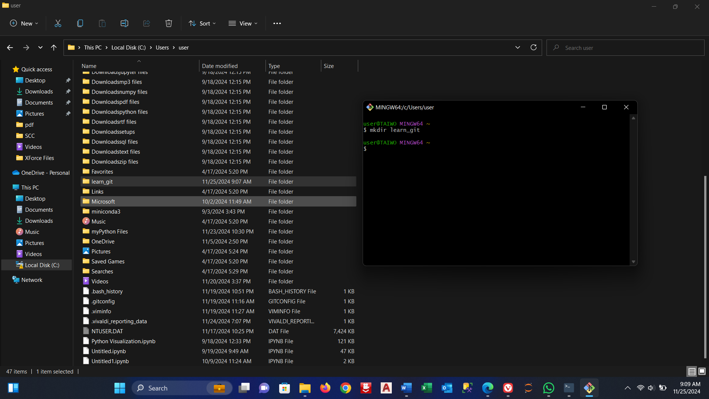

1. **Cd (change directory) into the learn_git folder**  
   Move into the newly created directory:

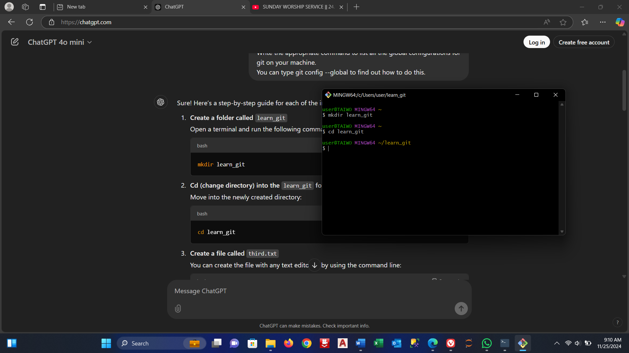

1. **Create a file called third.txt**  
   You can create the file with any text editor or by using the command line:

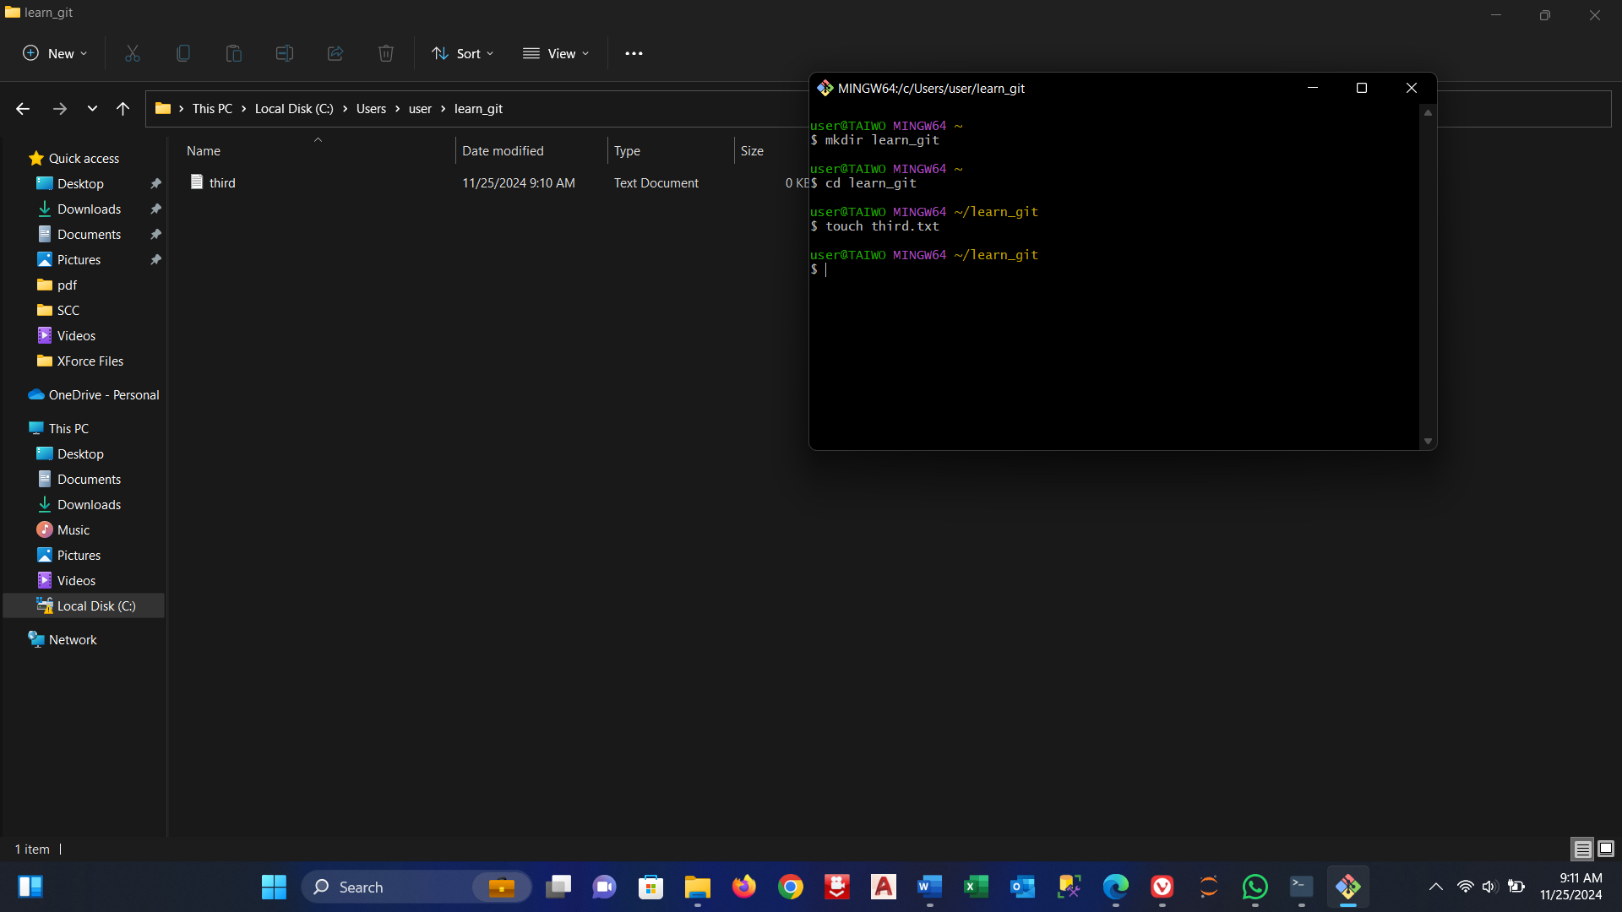

1. **Initialize an empty git repository**  
   Run the following command to initialize a Git repository in this folder:

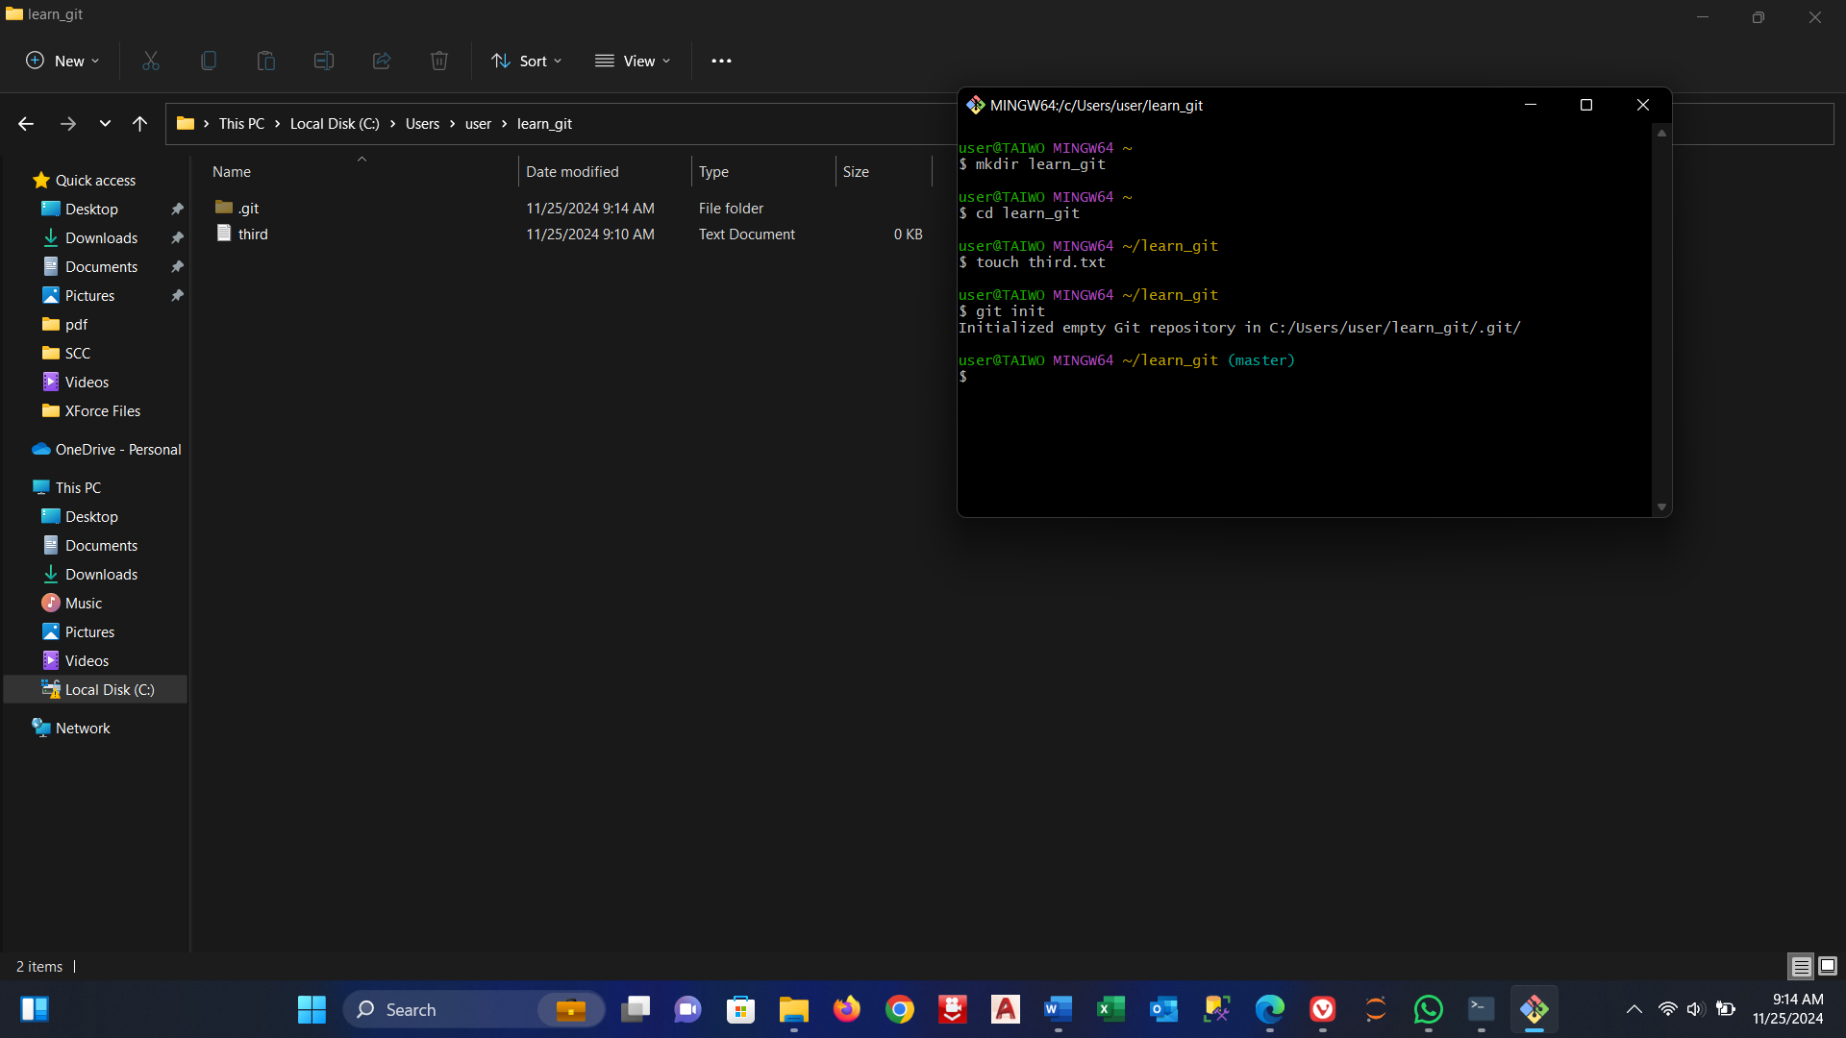

1. **Add third.txt to the staging area**  
   Add the file third.txt to the staging area:

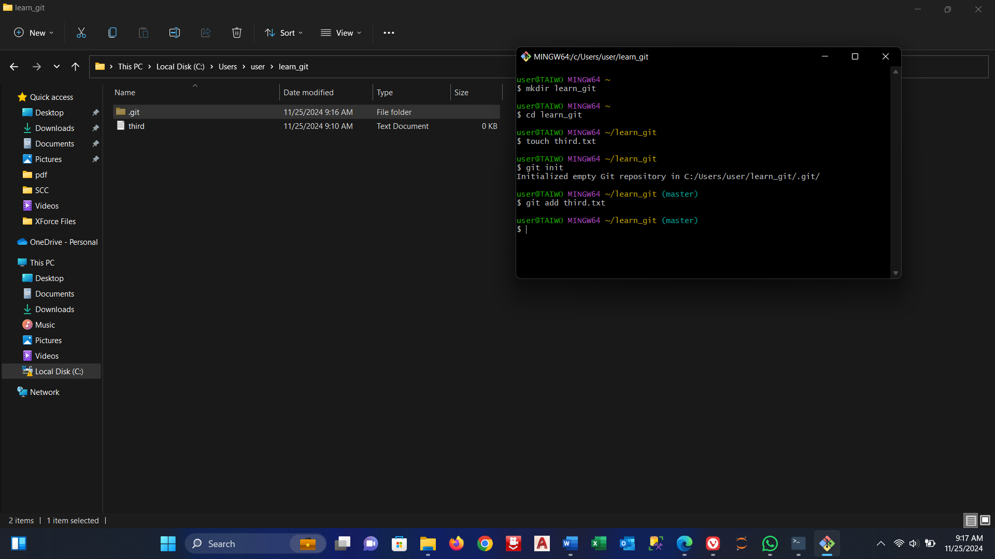

1. **Commit with the message "adding third.txt"**  
   Commit the changes with an appropriate commit message:

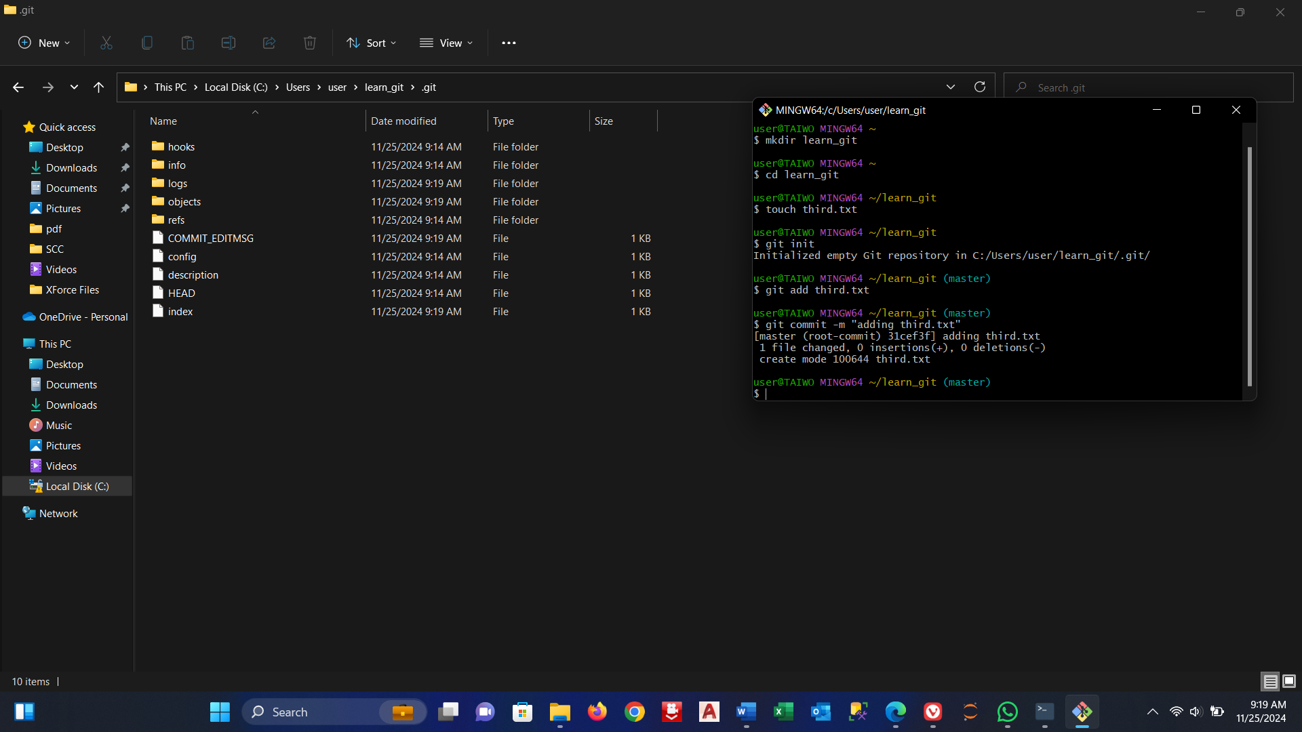

1. **Check out your commit with git log**  
   View the commit history to confirm that the commit was made:

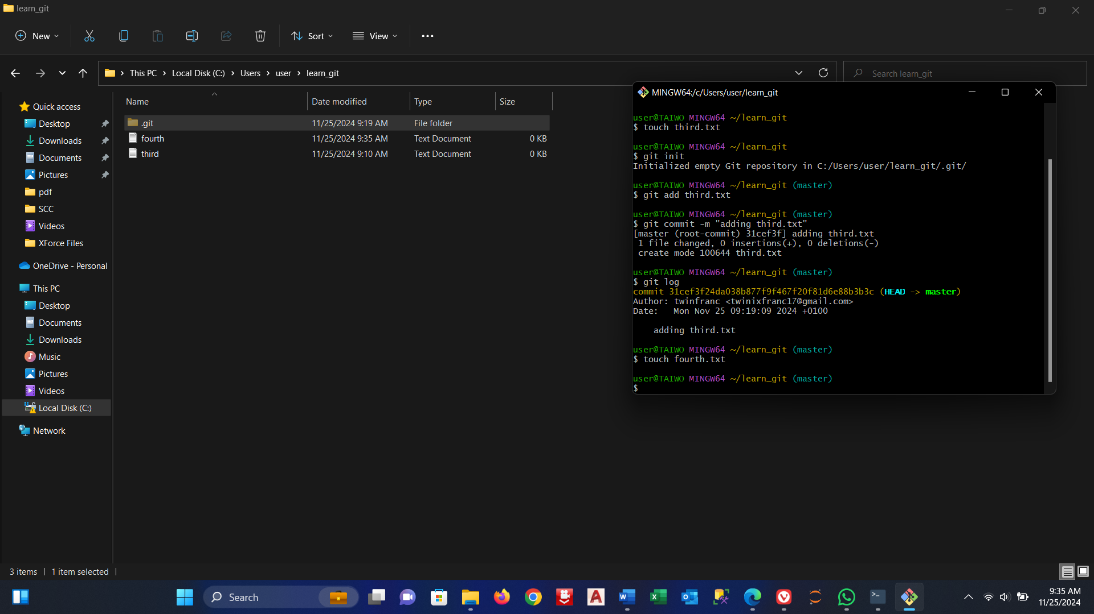

1. **Create another file called fourth.txt**  
   Create the new file fourth.txt:

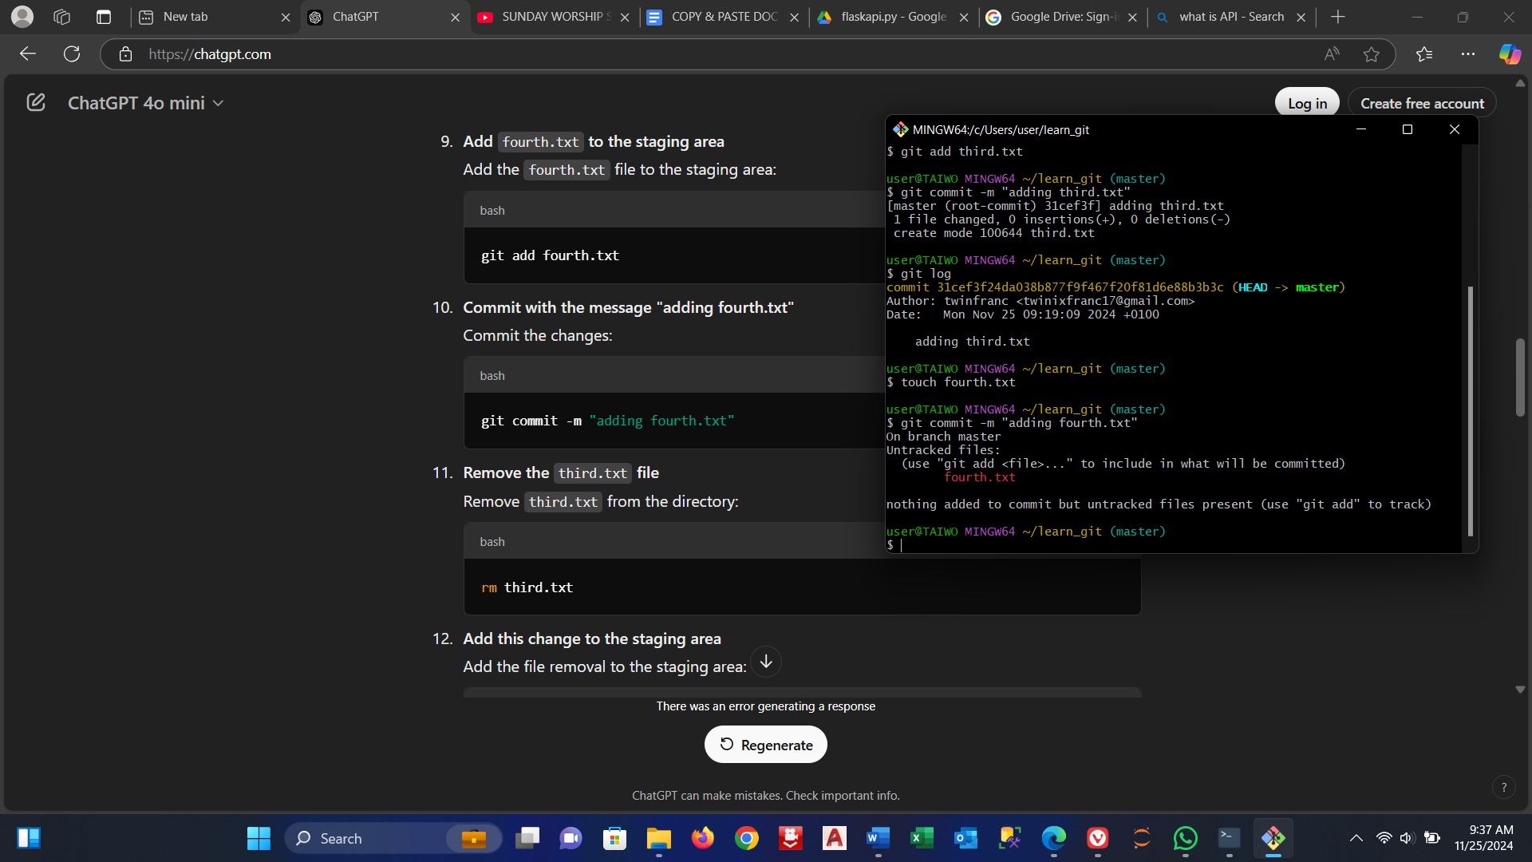

1. **Add fourth.txt to the staging area**  
   Add the fourth.txt file to the staging area:

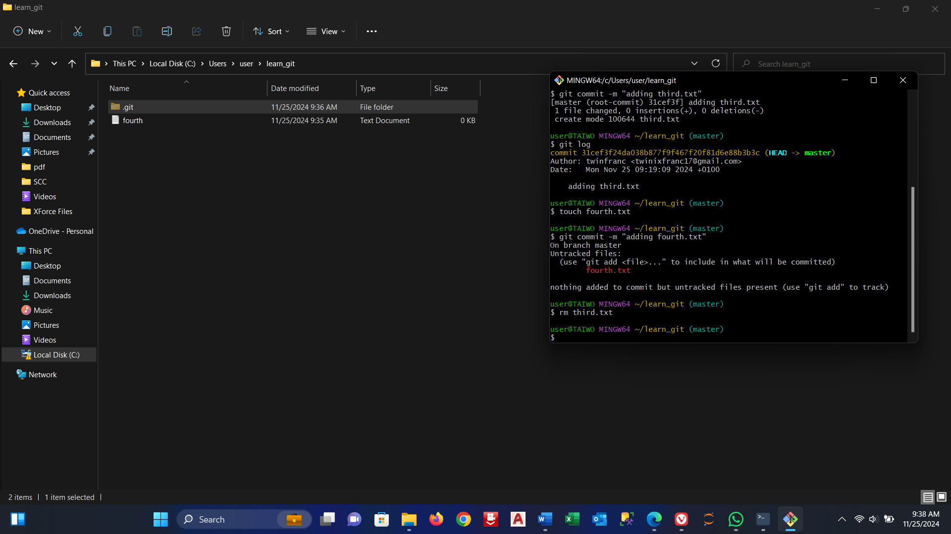

1. **Commit with the message "adding fourth.txt"**  
   Commit the changes:

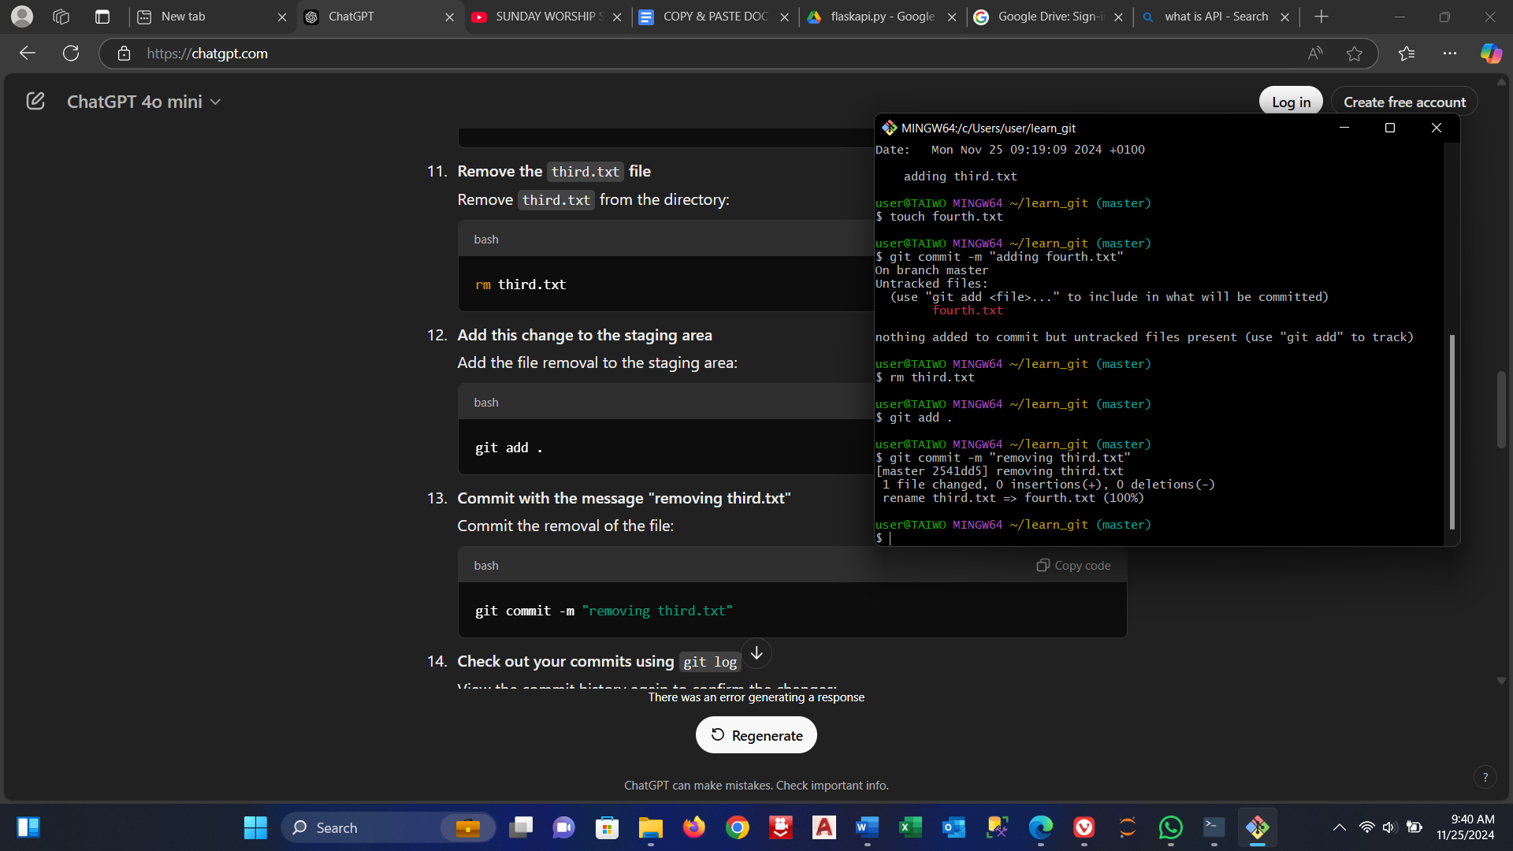

1. **Remove the third.txt file**  
   Remove third.txt from the directory:



1. **Add this change to the staging area**  
   Add the file removal to the staging area:

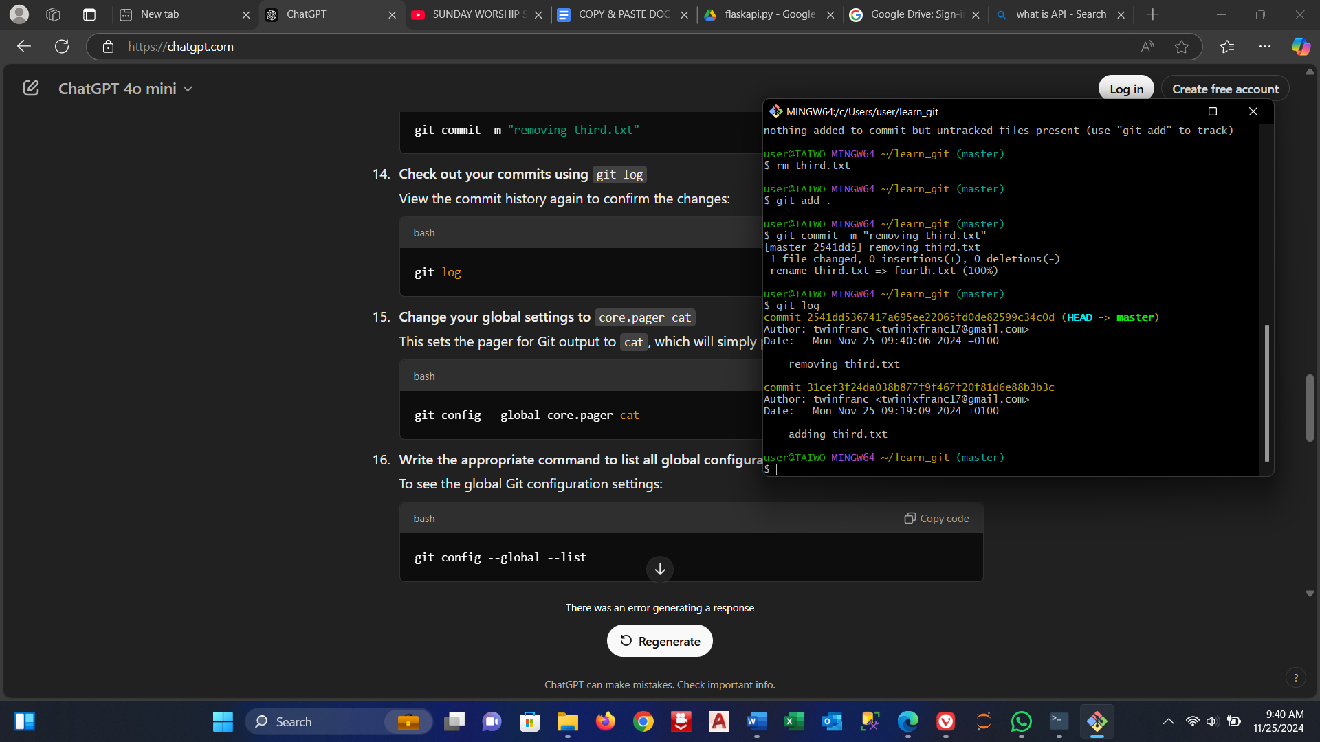

1. **Commit with the message "removing third.txt"**  
   Commit the removal of the file:

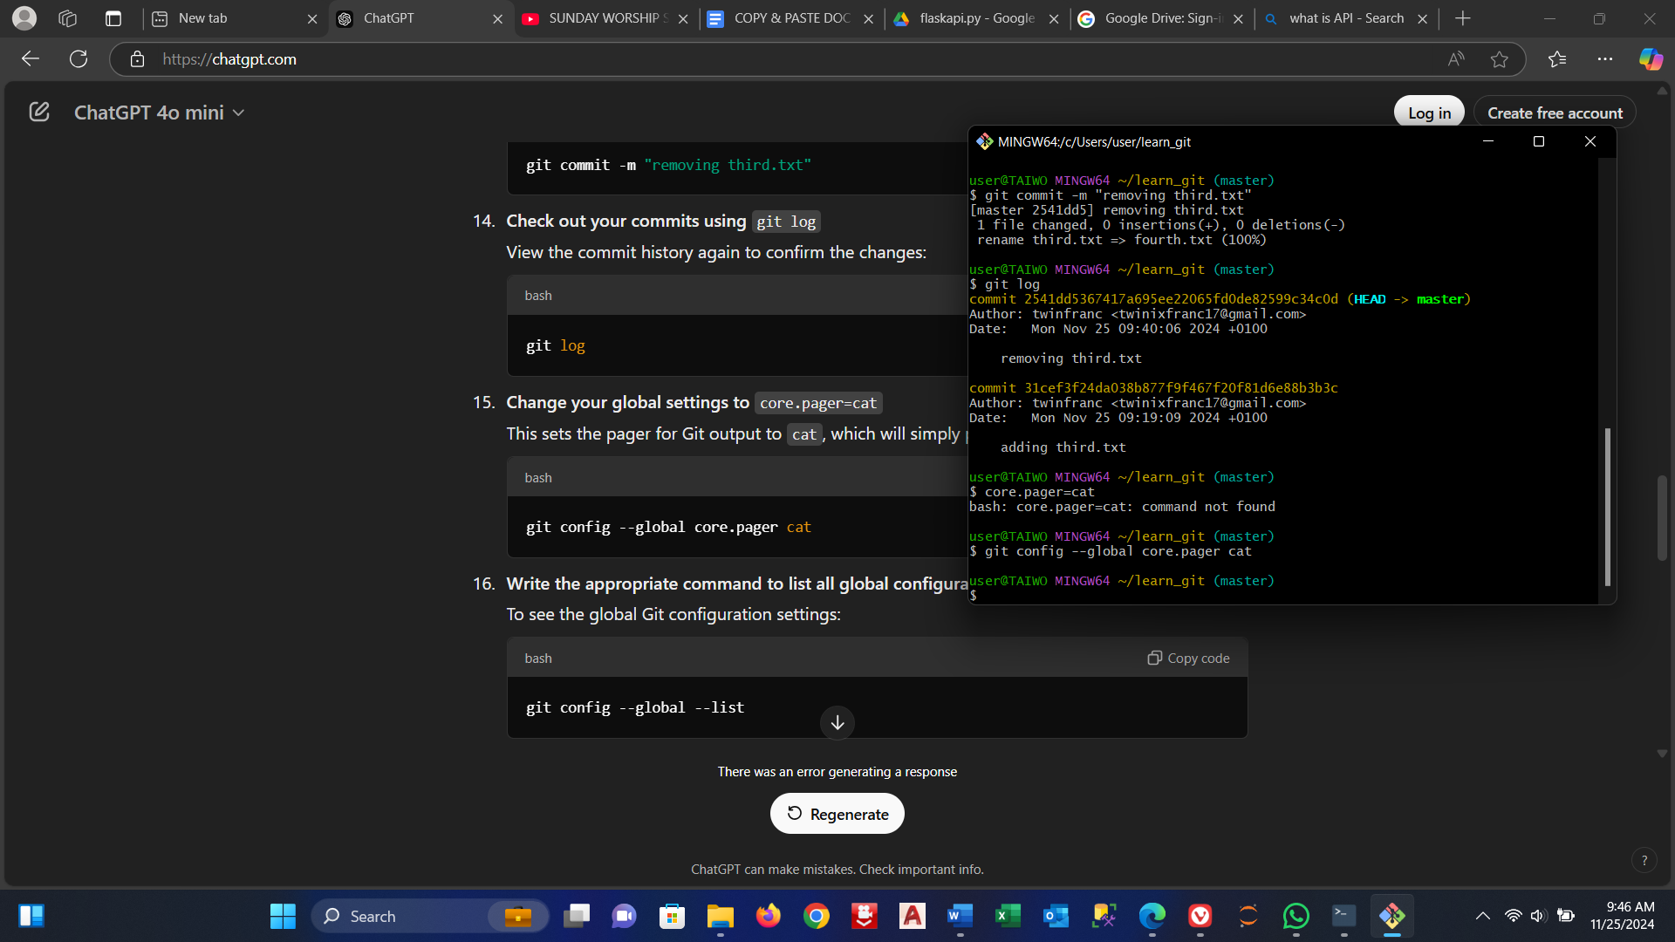

1. **Check out your commits using git log**  
   View the commit history again to confirm the changes:

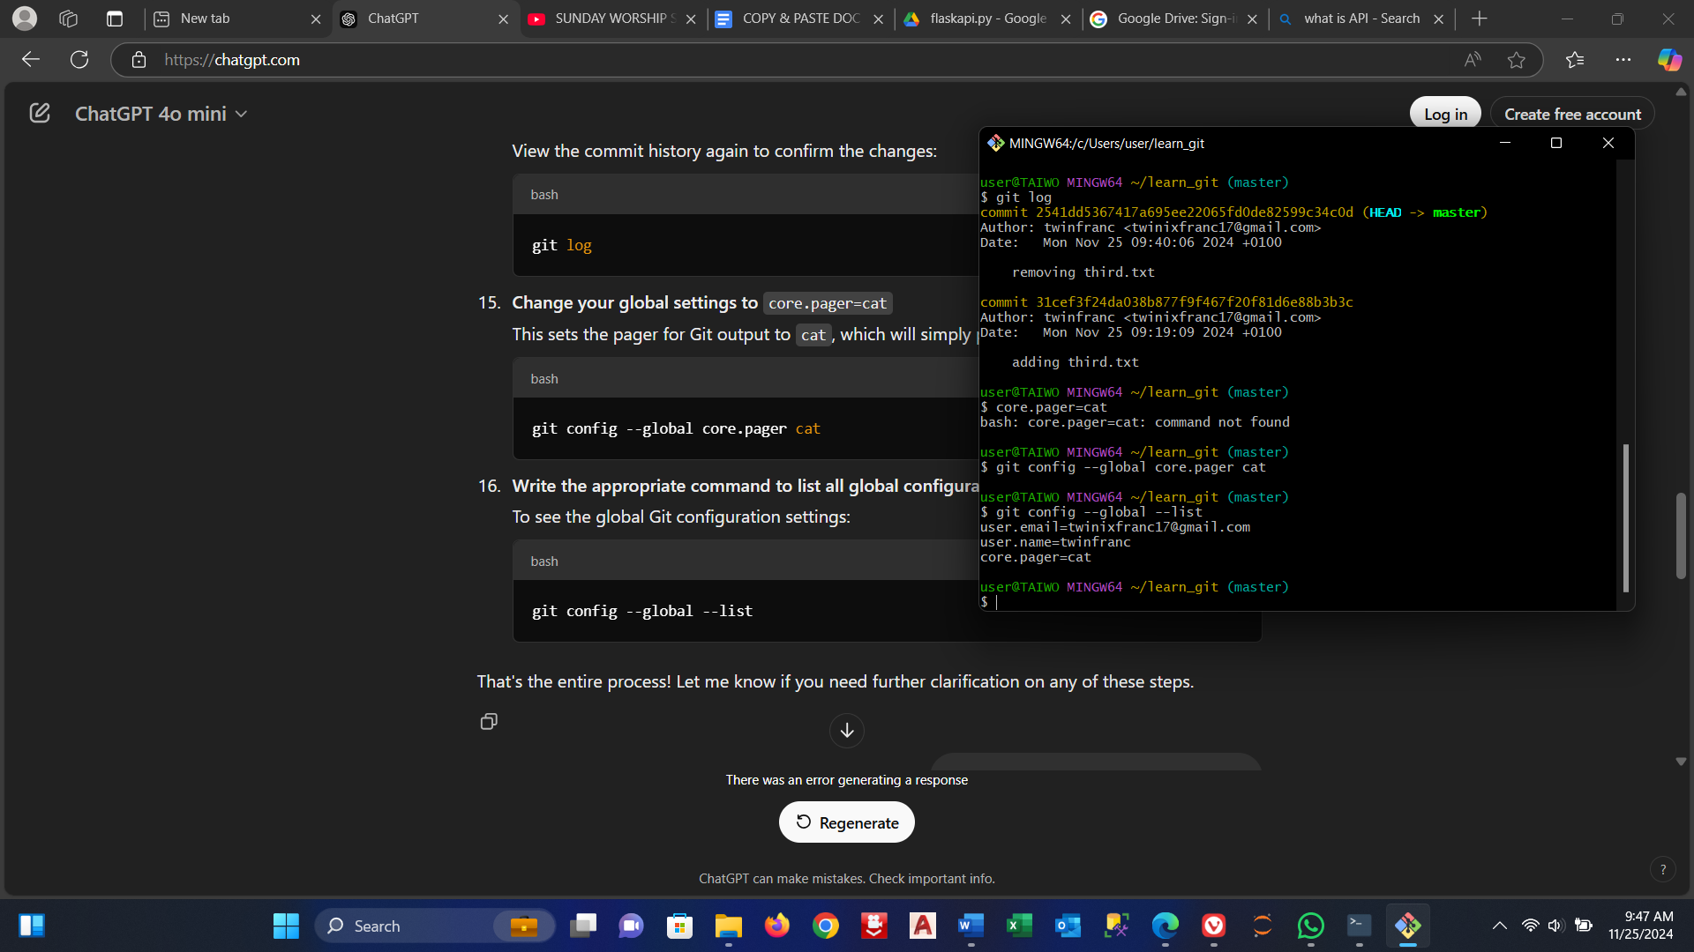

1. **Change your global settings to core.pager=cat**  
   This sets the pager for Git output to cat, which will simply print the output without paging:\

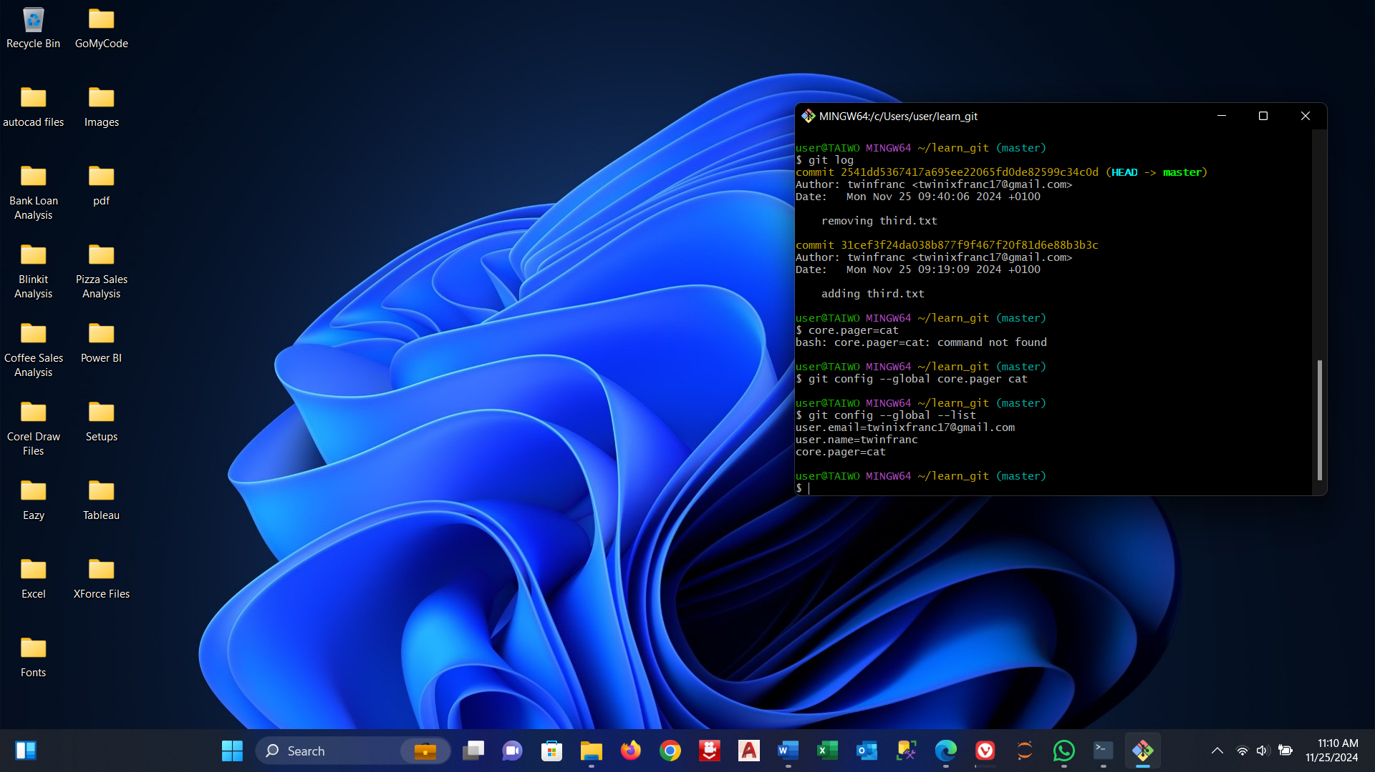

1. **Write the appropriate command to list all global configurations for Git on your machine**  
   To see the global Git configuration settings:

